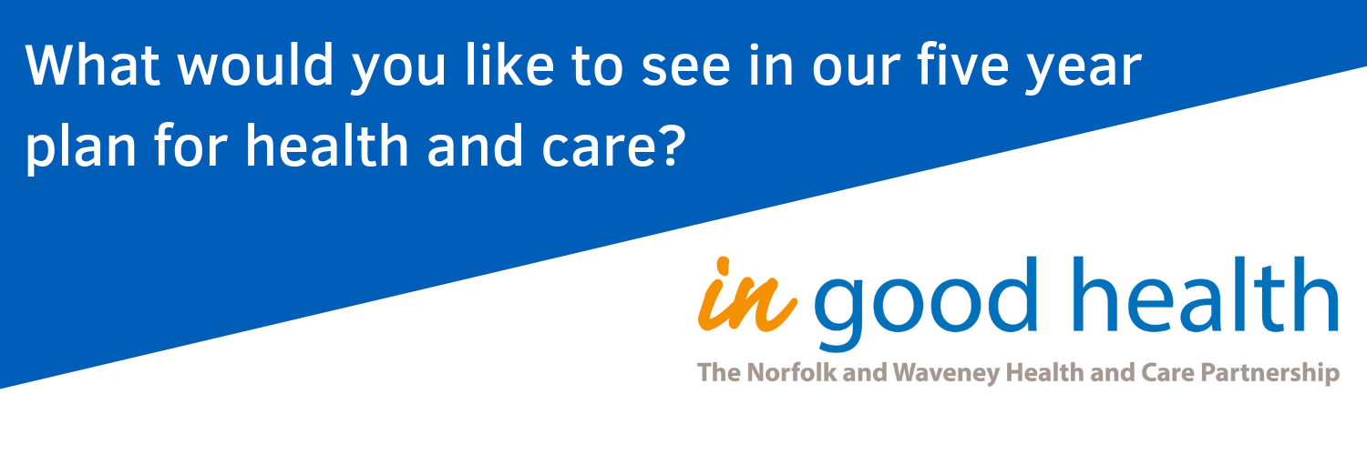
Making Norfolk and Waveney a healthier place to live
Every day we make choices that affect our own health and wellbeing, and many of us spend time caring for other people too - our partners, children, parents and friends. As a result, we all have lots of experiences of caring for others, and being cared for.
Local NHS and care organisations are working together to develop a five year plan for health and care in Norfolk and Waveney. We need you to turn all your experiences into good ideas about how we can improve the health and wellbeing of people living locally.
Join our online conversation to share your ideas about how we can make Norfolk and Waveney a healthier place to live, and to see what other people are saying too.
Your ideas might just save a life, so get involved and tell us what you want to see in our five year plan for health and care.

