NORFOLK COUNTY COUNCIL has made a Temporary Traffic Order affecting the St Leonards Street from its junction with Crown Road for a distance of 100 metres westwards in the PARISH OF MUNDFORD because of mains laying.

The road will be temporarily closed (except for access) from 29th July 2019 to 2nd August 2019 for the duration of the works, expected to be 5 days within the period.

Alternative route is via: St Leonards Street, Cranwich Road, Swaffham Road Roundabout, Swaffham Road, Crown Road.

(If necessary the restriction could run for a maximum period of 18 months from the date of the Order).

Penalty: £1000 maximum fine on conviction and/or endorsement for contravention.

In the event of the start date being delayed the new start date will be displayed on site in advance.

The person dealing with enquiries at Norfolk County Council is Adam Mayo (Community and Environmental Services) Telephone 0344 800 8020.

Dated this 26th day of July 2019

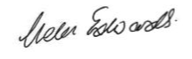

Helen Edwards
Chief Legal Officer

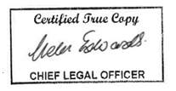

County Hall
Martineau Lane
Norwich
NR1 2DH

